Cummins Area School Uniform
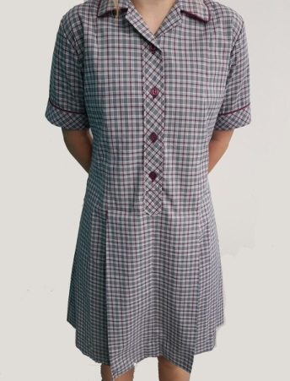
The school’s colours are maroon and dark grey

Tops - maroon embroidered school jumper
- maroon embroidered school polo shirt

Bottoms - dark grey pants
- dark grey shorts
- girls dark grey skort

School Dress – grey/maroon check

All items are available through the school’s online shop at Sportscentre.com.au
http://www.sportscentre.com.au/products/buy-online/school-uniforms/cummins-area-school
Families can choose to purchase the dark grey bottoms from any retailer, however they are to be the same colour as the online options and have no commercial logo’s larger than a 50c piece. Shorts need to be an appropriate length for school, as do dresses.
It is a school policy that hats are worn. Maroon broadbrimmed hats are available for purchase through the front office.
School bags are also available from the front office in two sizes – large and small.
A commemorative Year 7 polo shirt and Year 12 jumper is available to order each year.
Interschool Sports uniforms and Show Team uniforms are owned by the school and loaned as appropriate to participating school team members.
Enclosed shoes or sandals are to be worn. Thongs or backless sandals are not acceptable.
Classes involved in activities such as PE, Ag and Tech may be able to change into clothes appropriate and safe for that activity. Students are to take direction from the teacher of that class.
